Document | SUPPLIER REGISTRATION MANUAL
Author | JAGGAER S.A.
Client | ENAGÁS

HISTORY OF CHANGES
Rev. n° | Date | Notes
0 | 03/08/2022 | First Version. Jaggaer Supplier Registration

INDEX
1. HISTORY OF CHANGES 1
2. INTRODUCTION 3
3. JAGGAER PLATFORM SUPPLIER REGISTRATION 3
ANNEX I 10
ANNEX II 17

INTRODUCTION

The purpose of this manual is to show which are the steps that the Supplier will have to follow to register in Jaggaer's platform.

JAGGAER PLATFORM SUPPLIER REGISTRATION
To begin the Supplier registration within the Enagás platform, the following steps must be followed:

  - The registration and access page will be the following: https://enagas.bravosolution.com/web/login.html. By clicking on "Register here", the Supplier will be able to begin the registration of its company in the Enagás Portal:

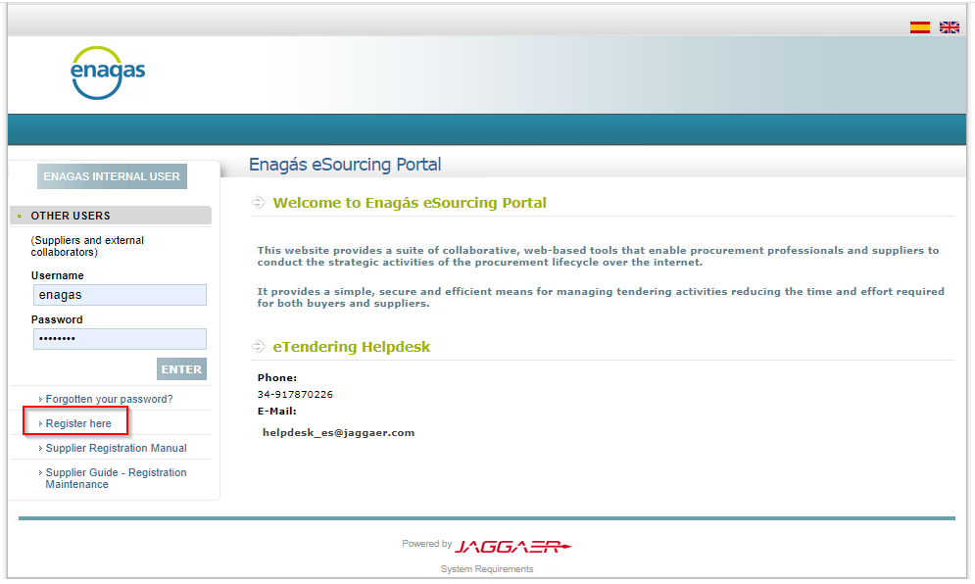

  - Next, the data of the company and the main user must be completed. All fields marked with an asterisk * are mandatory fields required to complete the process.
IMPORTANT: the email associated to the main user will be the same one that receives both the access credentials and all invitations to bids.

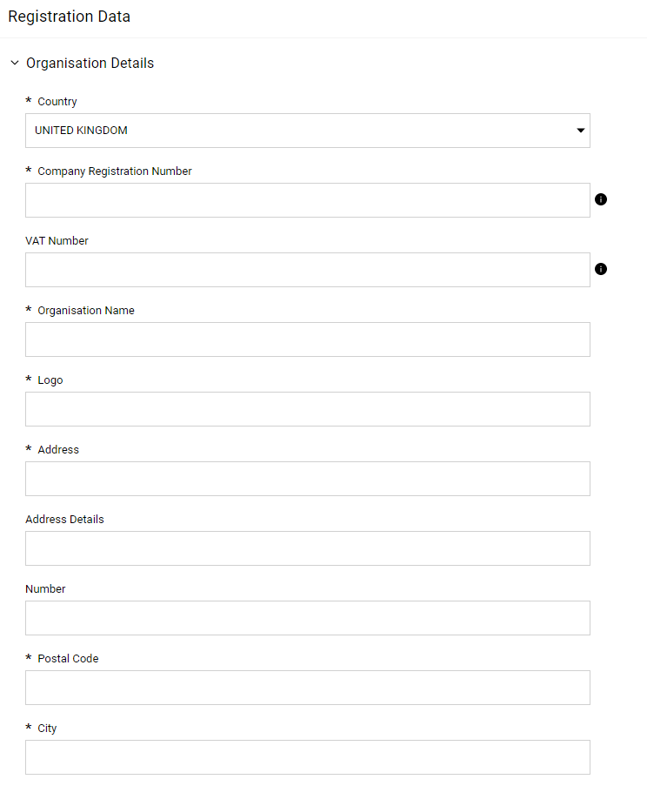
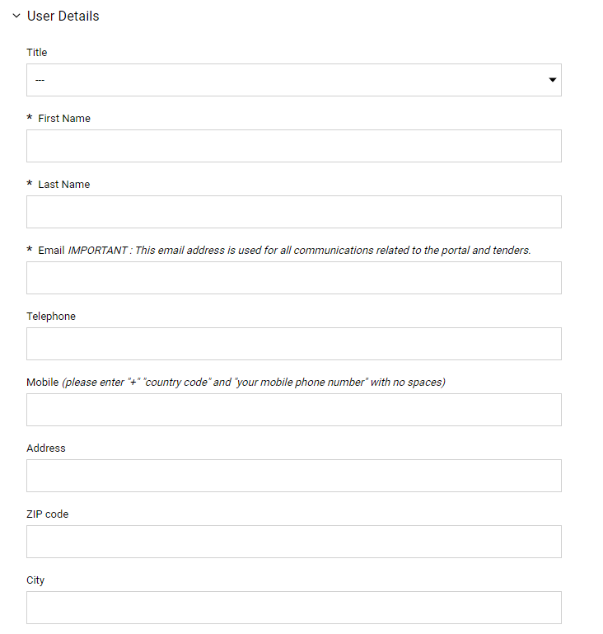

  - Once all registration is complete, click on "Save”:

  - After clicking on save, the system will automatically send an email with the access credentials:
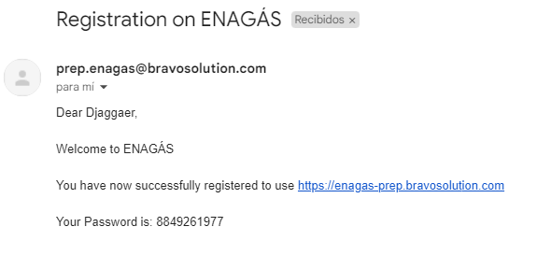

  - Likewise, the system will require the Financial Data to be completed:

NOTE: in section 5 the tax identification card must be attached where the following is shown: company name, tax address and CIF code or VAT NUMBER:

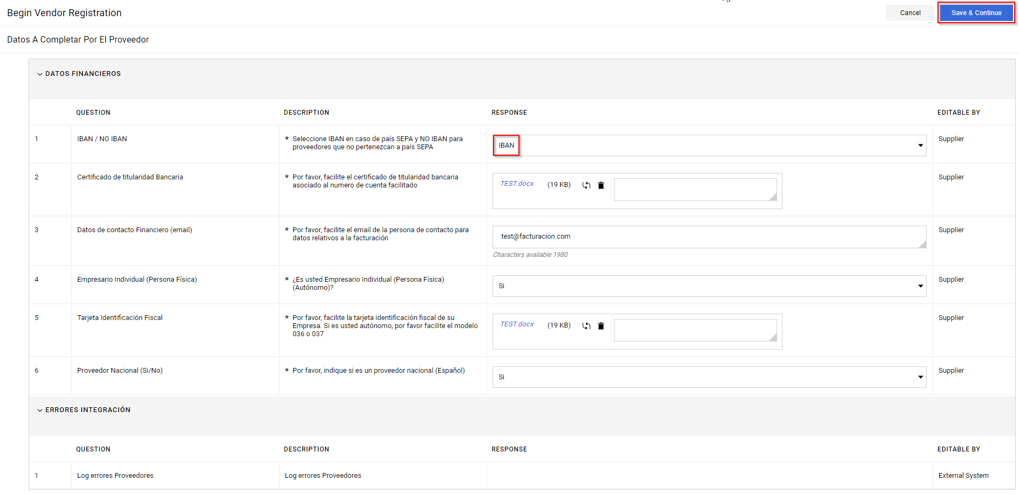

  - Once the financial fields have been completed, depending on whether IBAN or NO IBAN is available, the corresponding data must be indicated. It will be mandatory to attach the bank ownership certificates issued by the bank; other documents such as bank statements, screenshots of the bank's website and similar will not be valid.

NOTE: In Annex I, at the end of this document, more information on IBAN and NO IBAN fields is provided.

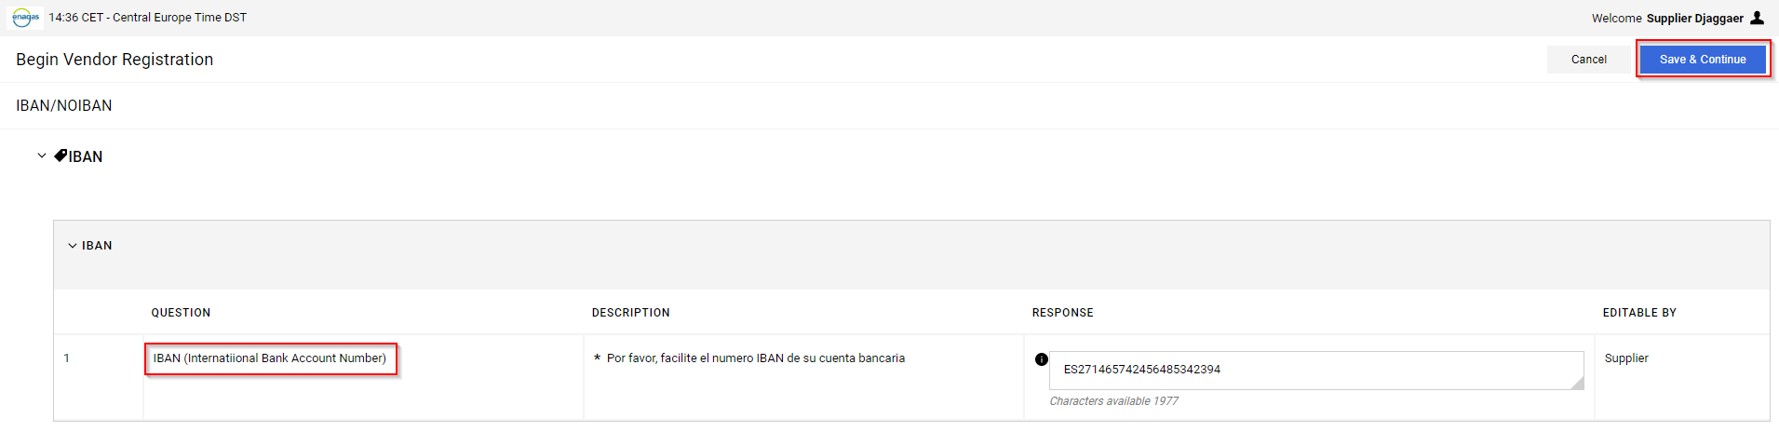

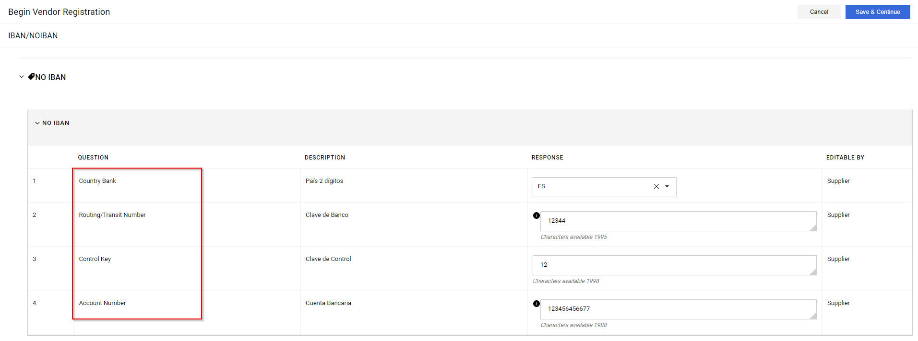

  - Also, depending on whether the supplier is an individual entrepreneur (self-employed) or not, the supplier will be required to fill in an additional form. Regarding this point, it will be mandatory to attach the form 036/037 or a certificate issued by the tax agency where the heading of the economic activity, name and surname, ID card number and tax domicile are shown:

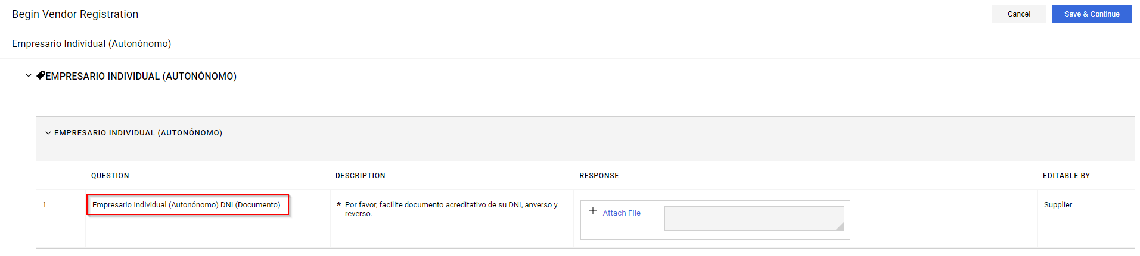

  - On the other hand, only in those cases in which the supplier is not national, it will also be required to complete an additional form. See Annex II.

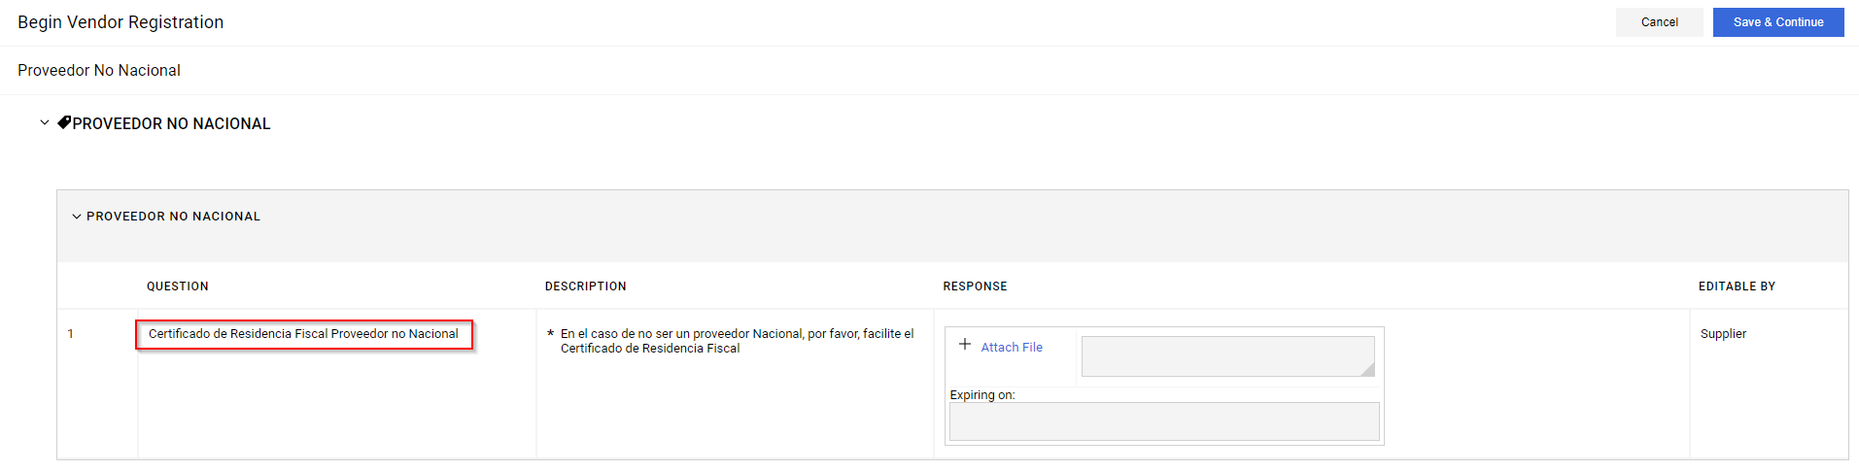

  - Finally, at least one category must be selected from the category tree. To do this, click on the different arrows to display the different subcategories according to the corresponding group. By clicking on the corresponding box, the option can be checked. Finally, click on "Confirm":
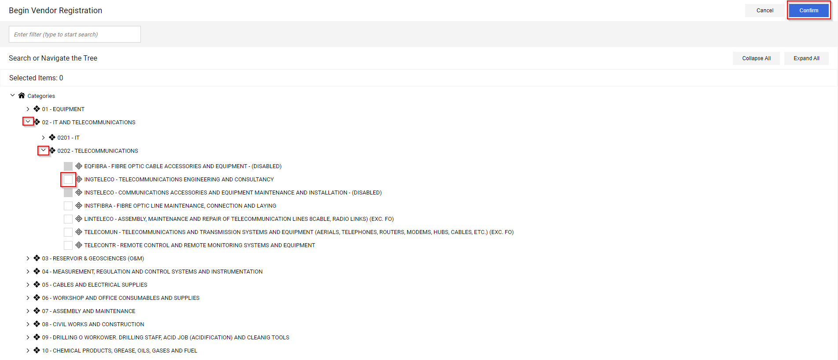

  - Once the registration is completed and all required fields are filled in, the account will be activated:

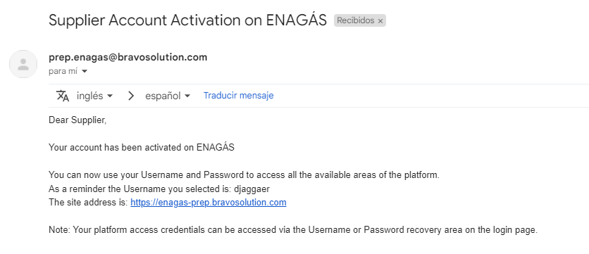

IMPORTANT NOTE
In the case of a change of tax address and company name, the initial registration data must be changed in JAGGAER and the tax identification card with the new data must be attached again. In case of a change of VAT number, the supplier must register a new supplier with the new VAT number.
For bank account modifications, the new bank ownership certificate must always be attached.

ANNEX I
REGISTRATION BANK DETAILS BY COUNTRY

- IBAN (International Bank Account Number)
The IBAN field is an alphanumeric number that can be up to 34 characters long.
Normally, the supplier will have the bank information and will have to fill in the bank details depending on whether IBAN is available or not. In the Jaggaer platform, and if the IBAN option is chosen, it should be in the format detailed in the attached table according to the supplier's country:

Country table implementing IBAN
Countries | Country Code | SEPA | Long | Sample
Albania | AL | No | 28 | AL35202111090000000001234567
Andorra | AD | No | 24 | AD1400080001001234567890
Azerbaijan | AZ | No | 28 | AZ96AZEJ00000000001234567890
Bahrain | BH | No | 22 | BH02CITI00001077181611
Belgium | BE | Yes | 16 | BE71096123456769
Bosnia and Herzegovina | BA | No | 20 | BA275680000123456789
Brazil | BR | No | 29 | BR1500000000000010932840814P2
British Virgin Islands | VG | No | 24 | VG21PACG0000000123456789
Bulgaria | BG | Yes | 22 | BG18RZBB91550123456789
Costa Rica | CR | No | 22 | CR37012600000123456789
Denmark | DK | Yes | 18 | DK9520000123456789
Germany | DE | Yes | 22 | DE91100000000123456789
Dominican Republic | DO | No | 28 | DO22ACAU00000000000123456789
El Salvador | SV | No | 28 | SV43ACAT00000000000000123123
Estonia | EE | Yes | 20 | EE471000001020145685
Faroe Islands | FO | Yes | 18 | FO9264600123456789
Finland | FI | Yes | 18 | FI1410093000123458
France | FR | Yes | 27 | FR7630006000011234567890189
Georgia | GE | No | 22 | GE60NB0000000123456789
Gibraltar | GI | Yes | 23 | GI04BARC000001234567890
Greece | GR | Yes | 27 | GR9608100010000001234567890
Greenland | GL | Yes | 18 | GL8964710123456789
Great Britain | GB | Yes | 22 | GB98MIDL07009312345678
Guatemala | GT | No | 28 | GT20AGRO00000000001234567890
Iraq | IQ | No | 23 | IQ20CBIQ861800101010500
Ireland | IE | Yes | 22 | IE64IRCE92050112345678
Iceland | IS | Yes | 26 | IS030001121234561234567890
Israel | IL | No | 23 | IL170108000000012612345
Italy | IT | Yes | 27 | IT60X0542811101000000123456
Jordan | JO | No | 30 | JO71CBJO0000000000001234567890
Kazakhstan | KZ | No | 20 | KZ563190000012344567
Qatar | QA | No | 29 | QA54QNBA000000000000693123456
Kosovo | XK | No | 20 | XK051212012345678906
Croatia | HR | Yes | 21 | HR1723600001101234565
Kuwait | KW | No | 30 | KW81CBKU0000000000001234560101
Latvia | LV | Yes | 21 | LV97HABA0012345678910
Lebanon | LB | No | 28 | LB92000700000000123123456123
Liechtenstein | LI | Yes | 21 | LI7408806123456789012
Lithuania | LT | Yes | 20 | LT601010012345678901
Luxembourg | LU | Yes | 20 | LU120010001234567891
Malta | MT | Yes | 31 | MT31MALT01100000000000000000123
Mauritania | MR | No | 27 | MR1300020001010000123456753
Mauritius | MU | No | 30 | MU43BOMM0101123456789101000MUR
Macedonia | MK | No | 19 | MK07200002785123453
Moldova | MD | No | 24 | MD21EX000000000001234567
Monaco | MC | Yes | 27 | MC5810096180790123456789085
Montenegro | ME | No | 22 | ME25505000012345678951
Netherlands | NL | Yes | 18 | NL02ABNA0123456789
Norway | NO | Yes | 15 | NO8330001234567
Austria | AT | Yes | 20 | AT483200000012345864
Pakistan | PK | No | 24 | PK36SCBL0000001123456702
Palestine | PS | No | 29 | PS92PALS000000000400123456702
Poland | PL | Yes | 28 | PL10105000997603123456789123
Portugal | PT | Yes | 25 | PT50002700000001234567833
Romania | RO | Yes | 24 | RO09BCYP0000001234567890
Saint Lucia | LC | No | 32 | LC14BOSL123456789012345678901234
San Marino | SM | Yes | 27 | SM76P0854009812123456789123
Sao Tome and Principe | ST | No | 25 | ST23000200000289355710148
Saudi Arabia | SA | No | 24 | SA4420000001234567891234
Sweden | SE | Yes | 24 | SE1412345678901234567890
Switzerland | CH | Yes | 21 | CH5604835012345678009
Serbia | RS | No | 22 | RS35105008123123123173
Seychelles | SC | No | 31 | SC52BAHL01031234567890123456USD
Slovak Republic | SK | Yes | 24 | SK8975000000000012345671
Slovenia | SI | Yes | 19 | SI56192001234567892
Spain | ES | Yes | 24 | ES1000492352082414205416
Timor Leste | TL | No | 23 | TL380080012345678910157
Turkey | TR | No | 26 | TR320010009999901234567890
Czech Republic | CZ | Yes | 24 | CZ5508000000001234567899
Tunisia | TN | No | 24 | TN4401000067123456789123
Ukraine | UA | No | 29 | UA903052992990004149123456789
Hungary | HU | Yes | 28 | HU93116000060000000012345676
United Arab Emirates | AE | No | 23 | AE460090000000123456789
Belarus | BY | No | 28 | BY86AKBB10100000002966000000
Cyprus | CY | Yes | 28 | CY21002001950000357001234567

The supplier or requesting unit must copy and paste the complete IBAN (with the number of characters shown in the table) into the IBAN field of the Jaggaer platform. It is important that this code is complete, in other words, if only the numbers are given but the letters of the country are not indicated, an error will occur, and the supplier will not be able to be created. The complete IBAN code must always be indicated (the table detailed above will help in case of doubt, but it will always be the supplier who will have to include or provide the complete information).

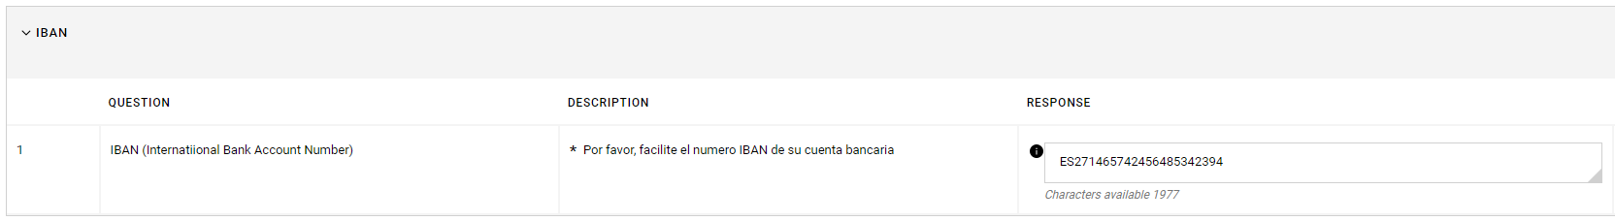

- NO IBAN
If the supplier does not have an IBAN and has a bank account format other than the IBAN structure, "NO IBAN" must always be indicated in the platform, and depending on the country, it will be completed in one way or another.
We detail a small guide by countries with which ENAGAS normally works.
We would like to emphasize that the purpose of this platform is for the supplier to fill in these data and not the requesting units, but in the exceptional case that suppliers have to be registered by Enagas or the suppliers have doubts on how to fill in these fields, the detailed indications will help both parties.
In JAGGAER, when selecting the NO IBAN option, the bank data record will appear with the fields in the attached screenshot:
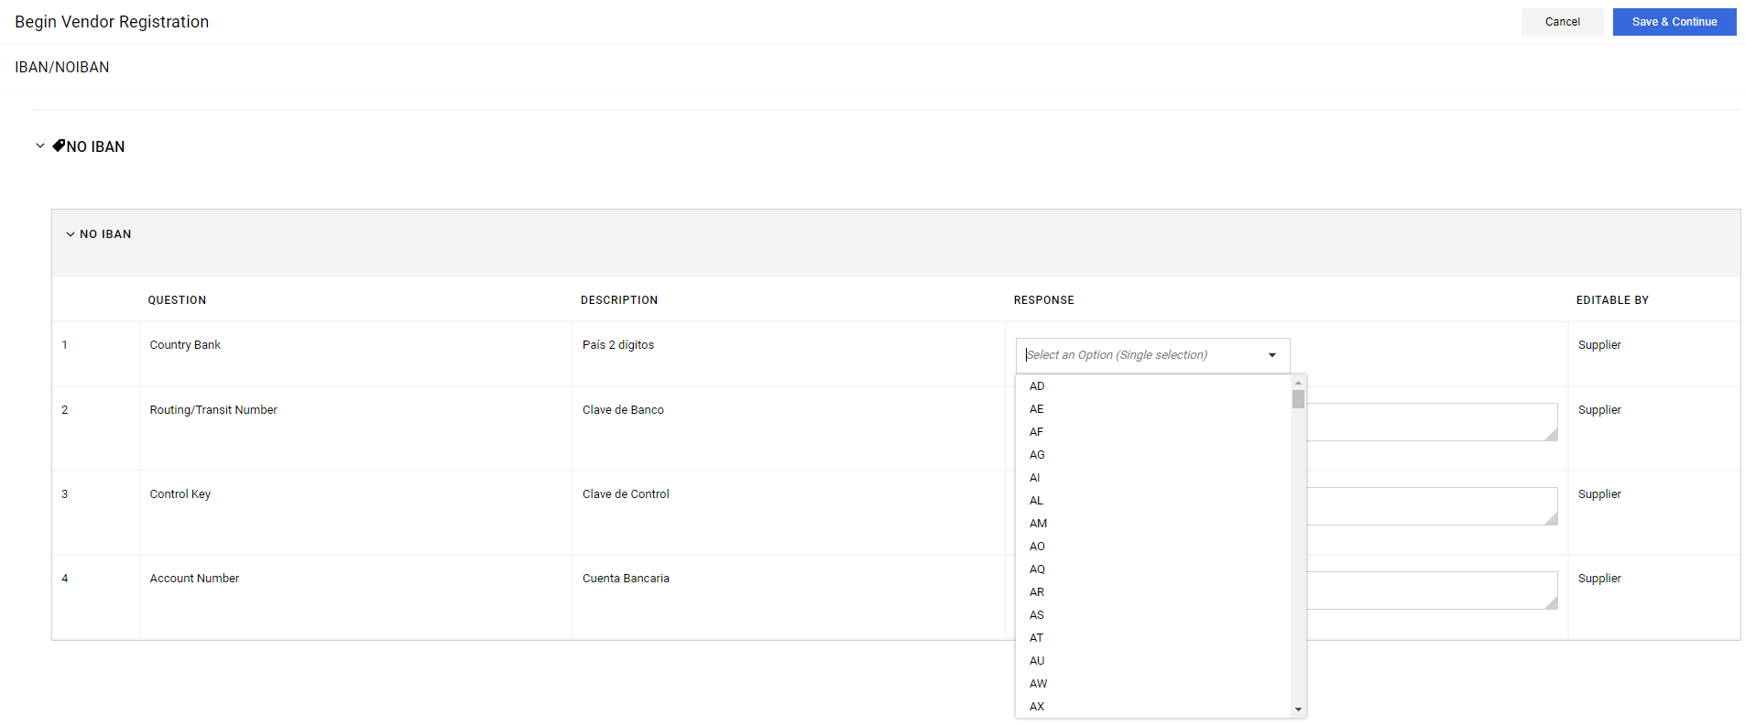

Depending on the country we will indicate the information in a different way, but the "Country Bank" field will always have to be selected from the drop-down list that appears.
1.Country Bank: select the applicable one from the drop-down list.
2.Bank key (Routing/Transit Number): this field will always be filled in.
3.Control Key: this field will only be filled in a few times (currently used for very few countries).
4.Account Number: this field will always be filled in.

UNITED STATES
Normally the documentation they send includes:
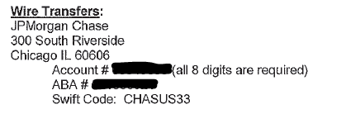
La The information in the "Account" field is what would be included in Jaggaer's item 4 "Bank Account" and the information in the ABA field (also called Routing Number or Transit) is what would be included in Jaggaer's item 2, in item 1 US would be chosen from United States and Jaggaer's item 3 does not apply in this case. As mentioned above, this field will rarely be filled in. Therefore, the information with USA would be as follows:

- Country Bank: US
- Bank Key (Routing/Transit Number): Provider documentation information that appears in the ABA or Routing Number description.
- Control Key: Not applicable
- Bank Account: Supplier documentation information that appears in Account or Account Number description.
AUSTRALIA

The way to register the information will be practically the same as in the United States with the difference that in field 2 of Jaggaer, you would have to include the information of the Australian supplier that appears in the description BSB or Bank Code. And the country selection will also be different.

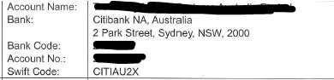
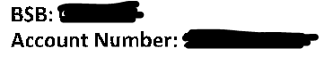

CANADA

Same process as USA and Australia with the only change in the description of Jaggaer point 2, in this case they call it "Transit". Field 1 country will always be changed to the country that applies, in this case Canada, we omit the country information from now on, but please remember this point.
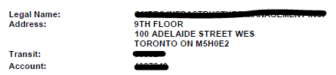
CHILE
Normally, Chile usually provides a bank account with the following structure: XXX-XX-XXXXX-X. The first three digits, that is, the first three X's, would correspond to field 2 Bank Key (Routing/Transit Number) and the rest of the digits would be unified and included in field 4 Account Number, that is:
- País Country Bank: CL
- Bank Routing/Transit Number: first three digits XXX
- Control Key: empty
- Account Number: rest of digits without hyphens, XXXXXXXXXX
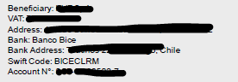
MEXICO

As in the previous cases, and we emphasize this point since there is no strict rule for all banks, the information that appears in Account No. /Account /Account Number... is what will generally always appear in field 4 of Jaggaer.
In the case of Mexico, we detail formats from different banks where the “No. de cuenta” is indicated (with 10 digits) and the field “No. Cuenta CLABE” contains the complete bank information including the “No. de cuenta” in the first field, that is, it is repeated in the last field. In these cases, the numbers that coincide with the “No. de cuenta” would remain in field 4 of Jaggaer and the rest of the numbers that appear in the last field, after extracting the “No. de cuenta”, would go in field 2 of Jaggaer:

- Country Bank: MX
- Bank Key (Routing/Transit Number): digits left over from the left of the CLABE Account No. field without taking into account the repeats in the Account No. field (XXXXXXX).
- Control Key: Empty.
- Account Number: first digits of the first field (Account No. XXXXXXXXXXXXXXXX)
In a different bank, the information appears the same way, the “No. de cuenta” would go in field 4 of Jaggaer and the information in CLABE again includes the “No. de cuenta” so the digits to the left of the “No. de cuenta” is the information that would go in field 2.

- Country Bank: MX
- Bank Key (Routing/Transit Number): left digits without taking into account the repeated digits of the Account No. field (XXXXXX).
- Control Key: Empty.
- Account Number: first digits of the first field (Account No. XXXXXXXXXXXXXXXX)

ANNEX II
TAX RESIDENCE CERTIFICATE FOR NON-NATIONAL SUPPLIERS

The tax residence certificate for non-national suppliers may vary depending on the country of origin. This information is required by the Tax Department. As an example, we detail three models from the United States, the United Kingdom and the Netherlands.

UNITED STATES
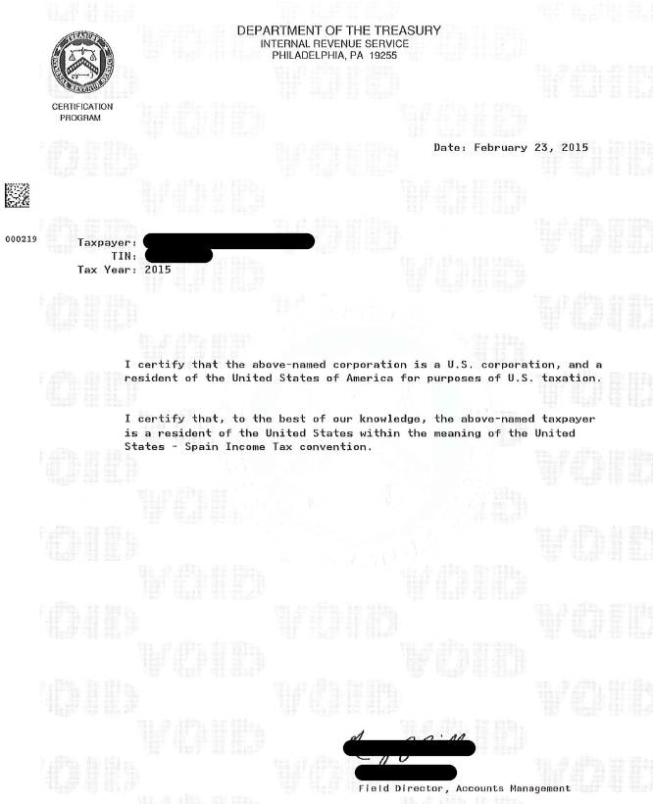

UNITED KINGDOM
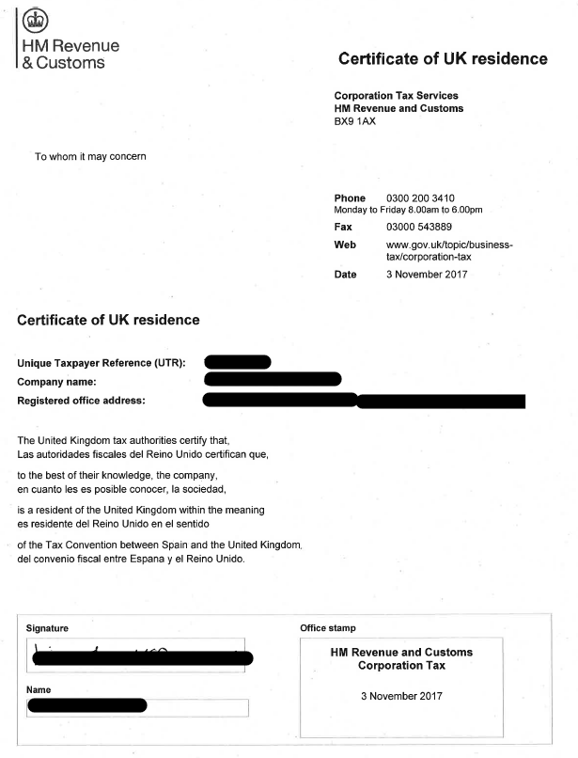

NETHERLANDS
